Module Test Plans:

1. Lookup Product –
   1. Generate Search Value: Users can select certain fields to sort available products by. Criteria includes Color, Size, and Price. Once the user selects a field that value is sent to the database to sort.
   2. Generate Match: Using the search value given by the user, the site runs a check on the database products to find products with matching criteria. If no matches are found, no products will be displayed.
   3. Item Details: When a user clicks on an item to view it, this brings up a page with the items photo, description, available sizes, in-stock quantity and colors. The user can then select from these criteria and add the corresponding item to their cart. (Users cannot exceed the Inventory Stock of available products and will be prompted such if they try to.)
   4. Generate Order: Once a user has added at least one item to their cart, the database generates an order for that user.
2. Update Cart –
   1. Calculate Totals: When viewing the cart, the products currently inside the users cart will have their quantities and respective prices combines to form a subtotal and displayed to the user.
   2. Display Cart: If the user click on the “Cart” button from the hot bar, it will bring them to their cart and display any products currently in their cart. From there the user can access Checkout.
3. Make Purchase –
   1. Finalize Purchase: Once a user has selected “Checkout” from the cart page, their order will be sent to a processing page. This transfers the users cart info into an order table to be stored as a completed order. Their cart is thus flushed after this check.
   2. Post Purchase: After the purchase check has been cleared, the user will have their order confirmed and given a prompt to return to the home page.
4. User Login –
   1. User/Admin Login: When users access the login page, they can enter their username and password to login to an associated account. Users and Admins share the same login page.
5. Manage User –
   1. Display User Information: If a user is logged in and enters the settings page, they will be shown all of their available information and a prompt to edit their information. If the user is not logged in, clicking settings will redirect to the login page.
   2. Edit User Information: Users logged in can edit their existing information from the settings page, users not logged in will be redirected to login.
   3. View Order History: Once a user has completed at least one order, they can view their order history from the settings page, to see any items from previous orders and their order status.
6. Manage Orders –
   1. Display All Orders: When an admin is logged in, they can check any completed orders, unauthorized users cannot access this page.
   2. Update Order Status: Admin users can update order statuses and edit them if need be.
7. Manage Product –
   1. Display Product: From the settings page, admin users can select the ProductID of any available product and edit it. This will first display the selected product’s information.
   2. Manage Inventory: After a product’s information is displayed, there is a form beneath the data to change any of the existing product info.
   3. Update Inventory: Once the admin has submitted the new information, the changes to the products fields will be entered into the database and updated.
   4. Add Product: Similarly to updating existing products, admins can add new products to the database using a similar form. Once completed the new data is sent to the database and the new product will become part of the stocked inventory.

Site Testing/Results:

Login Test- When attempting to Login, if the credentials do not match any on file, the page will display a message stating so to the user, prompting them to try again.

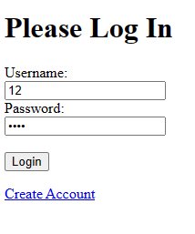 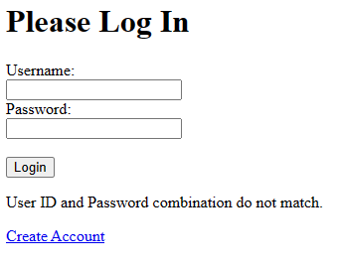

User / Admin Test- Depending on the users permissions, certain options will or wont be available in the settings page as seen below, preventing unauthorized users from editing or adding product data.

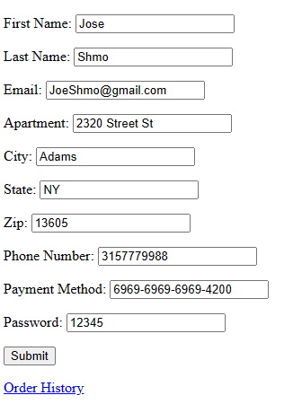

(User’s Screen)

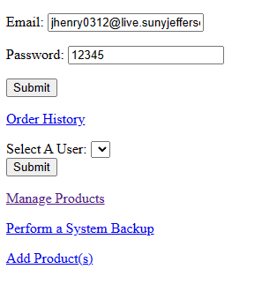

(Admin’s Screen)

Inventory Test – When a user attempts to purchase an item with no inventory stock, the button to add said item to the cart will be unavailable.

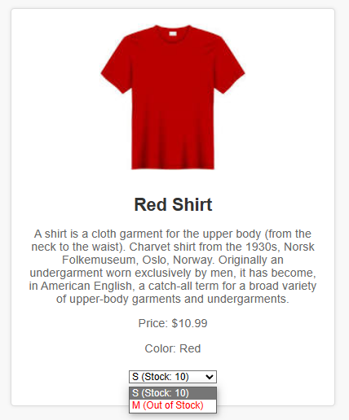

Product Search Test – If a user tries to search for an item not present in the inventory, text will be displayed to the user saying “No products found”.

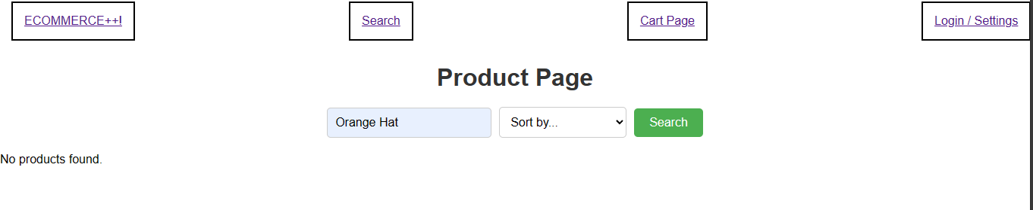

System Integration Testing:

